Programme and module responsibilities
If you have not already done so - it is important that you engage in a conversation with the relevant programme leader, module leader(s) or induction mentor as to how you might be expected to use technologies for teaching, learning and assessment.
Concerning the use of Blackboard, it is the Module Leader who has overall responsibility for the module online. However, the online module is populated with content by individual members of the teaching team. Some programmes/modules take a prescribed/collegiate approach, whereby there is a consistent approach across all modules in terms of how/what technology is used and how the online teaching, learning and assessment content is structured and presented. Whereas others allow individual tutors to make their own decisions as to how they will be using technology in their teaching and how their online content is structured and presented. In many cases this relates to the nuances of teaching, learning and assessment in different fields of practice.
Training sessions in the generic use of our core teaching, learning and assessment technologies can be accessed via My DMU Hub as follows:
- In your web browser navigate to My DMU Hub at: https://dmuhub.dmu.ac.uk/ and log in
- Click the My Development tile
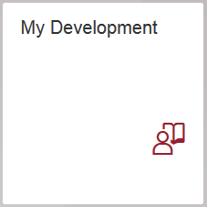
- In the Links panel click Browse Catalogue
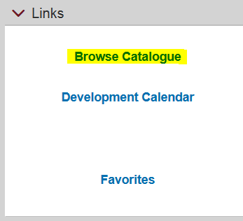
- In the Course Catalogue menu click Enhancing Learning through Technology
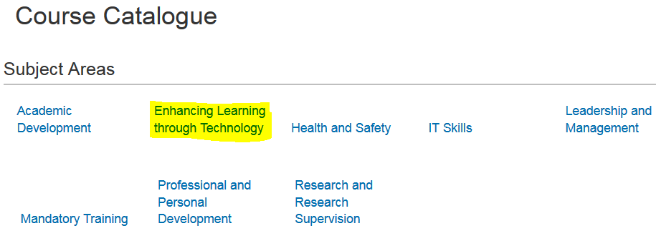
- Select a training and development session from the list
