Student induction and support in the use of learning technology
In line with the DMU Threshold for the use of Technologies in the Curriculum - it is the responsibility of programme and module teams, and where appropriate/necessary individual tutors to ensure that their students understand how and why specific technologies are being used to support teaching, learning and assessment. Students should also be made aware of how they are expected to use the technologies in their learning, in the context of your teaching/curriculum.
There are some online Student IT Support and Induction materials which you may wish to signpost for students. These can be found on the DMU Library website at: https://libguides.library.dmu.ac.uk/c.php?g=654033
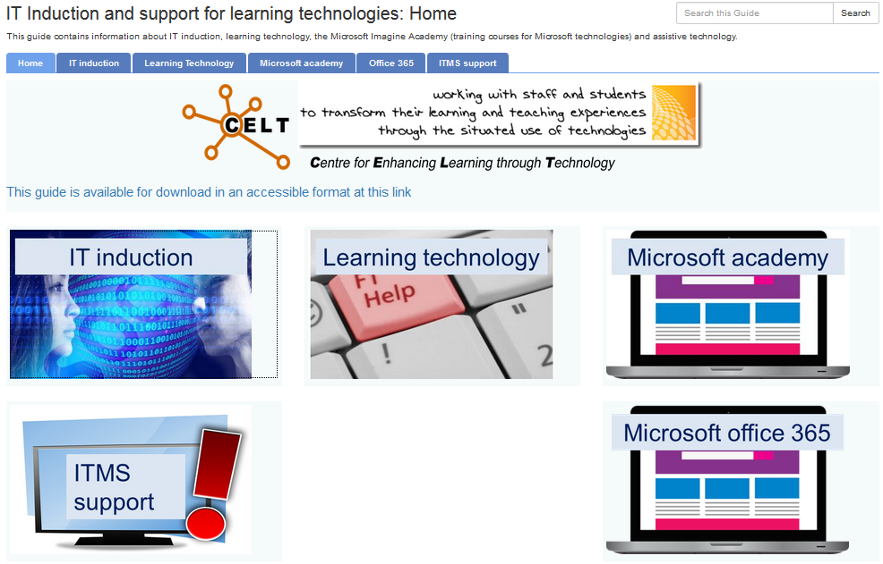
Our online teaching, learning and assessment space is the Virtual Learning Environment (VLE) called Blackboard. All modules have their own area in Blackboard in which online teaching, learning and assessment can be facilitated.
There is an online help guide for students in Blackboard - it can be accessed via the UserGuide tab.
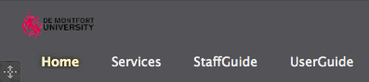
NOTE: this guide only offers general, generic information about Blackboard - therefore it is important that students are informed of the nuanced ways in which technology is being used in your module and how they are expected to use the technology.
Where do students go to get support if they are having problems with the teaching, learning and assessment technology?
If a student/students is/are having problems with any of the teaching and learning technologies; such as - the VLE (Blackboard), Turnitin or DMU Replay, there are several routes through which they can get support:
- They can report the issue to their module tutor. If the module tutor is unable to resolve the issue the tutor should contact their local ELT Project Officer explaining what the problem is. The ELT project Officer will investigate the problem and will reply to the module tutor, who can then pass on the information to their student(s).
- They can use the Just Ask service in the Kimberlin Library:Call the Just Ask service on 0116 257 7042
Drop by the Just Ask help desk on the 1st floor of the Kimberlin Library
Complete a Just Ask query form
http://www.library.dmu.ac.uk/Support/Justask/index.php?page=173

