Using a Blockbuster quiz in the classroom
1. Open the Blockbuster quiz in PowerPoint and go into presentation view.
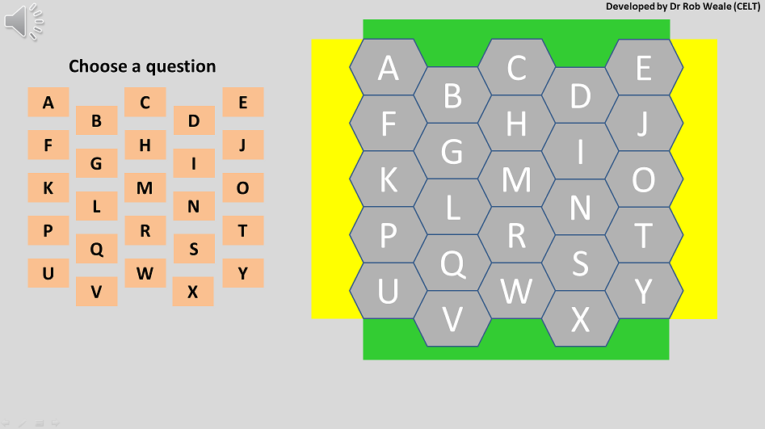
2. To reveal a question - click on the appropriate letter in the ‘Choose a question’ grid. The selected letter will turn Blue. E.g. A. The question text will appear at the bottom of the screen (in the blue rectangle).
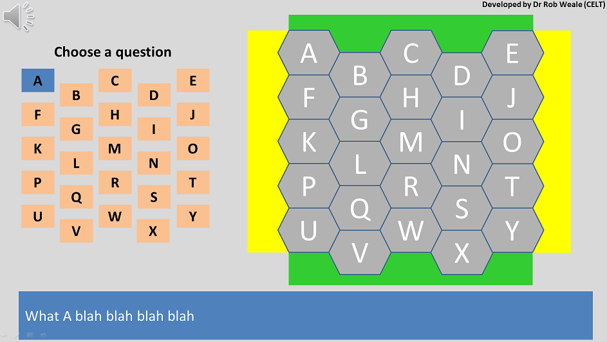
3. To indicate which team (yellow or green) has got the correct answer - toggle the colour of the appropriate hexagon by clicking it. The hexagons will toggle between three colours – Grey, Yellow, Green and back to Grey.
4. You must then toggle the current question off by clicking the letter in the choose a question grid. E.g. A is toggled off – it goes from blue back to orange.
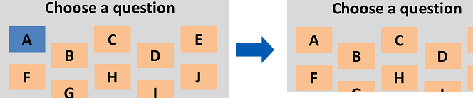
If you do not toggle the current question off you will not be able to see the next question when it is selected. E.g. both question A and B are selected below – but only question A can be seen.
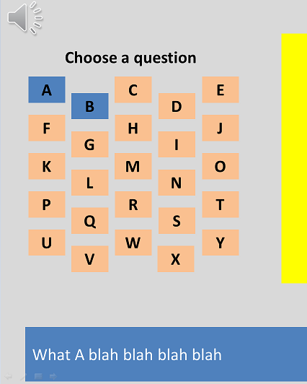
5. Toggle off question A and question B will be displayed.
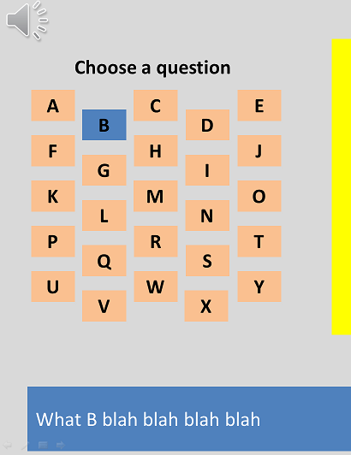
6. If no one gives the correct answer for a question you can use one of the extra questions that you set up.
7. Click on an extra question number to reveal the extra question. Note: the previous question must be hidden in order to see the extra question.
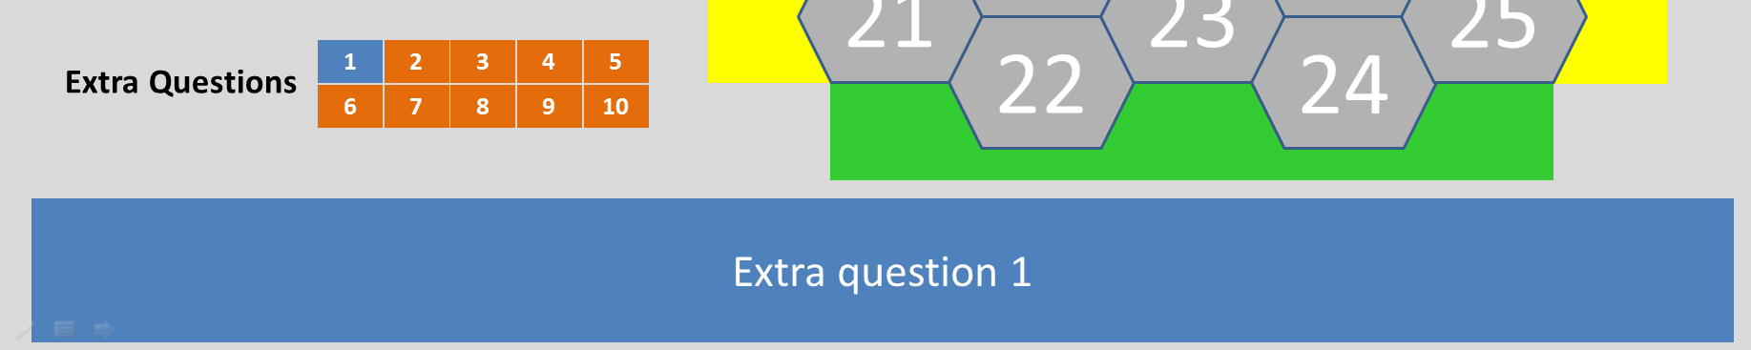
8. When the question has been answered click the extra question number again to hide the extra question box. The question number will turn red to indicate that it has already been asked. You can now continue to ask the regular questions.
