Using the virtual computers and desktop during synchronous sessions
Note:
- The virtual access software is only accessible on Chrome and Firefox. Ensure you are familiar with accessing the virtual labs before you introduce it in a synchronous session.
- Before you introduce the virtual labs ensure you are familiar with managing Teams synchronous sessions.
- Do not record students content.

Learning outcomes
By the end of this guide you should know how to;
- use YourDMULabs during a MS Team meeting (Windows users).

How to

Using YourDMULabs during a MS Team meeting
1. Join the MS Team meeting in which you intend to share the virtual lab.
2. Open a browser, either Chrome or Firefox, window and sign into the virtual access software using the url: yourDMUlabs.dmu.ac.uk
3. Return to the MS Team meeting and select Share content.
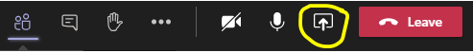
Note: If you wish the students to hear the computer audio, for example from an animation clip, ensure you select Include computer audio from the share content pane.
4. Select the browser window that is running the Horizon dashboard.
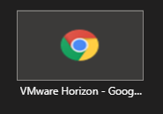
5. When you have finished using the Horizon software select stop sharing in MS Teams.
Note: Don’t forget to log out from the desktop or software you were running on the virtual lab and then log out of the Horizon dashboard.

